Amy Nestingen

DSC 630

9/15/2020

Week 3 and 4 Exercise: Line Charts and Step Charts

# Python

Line Chart

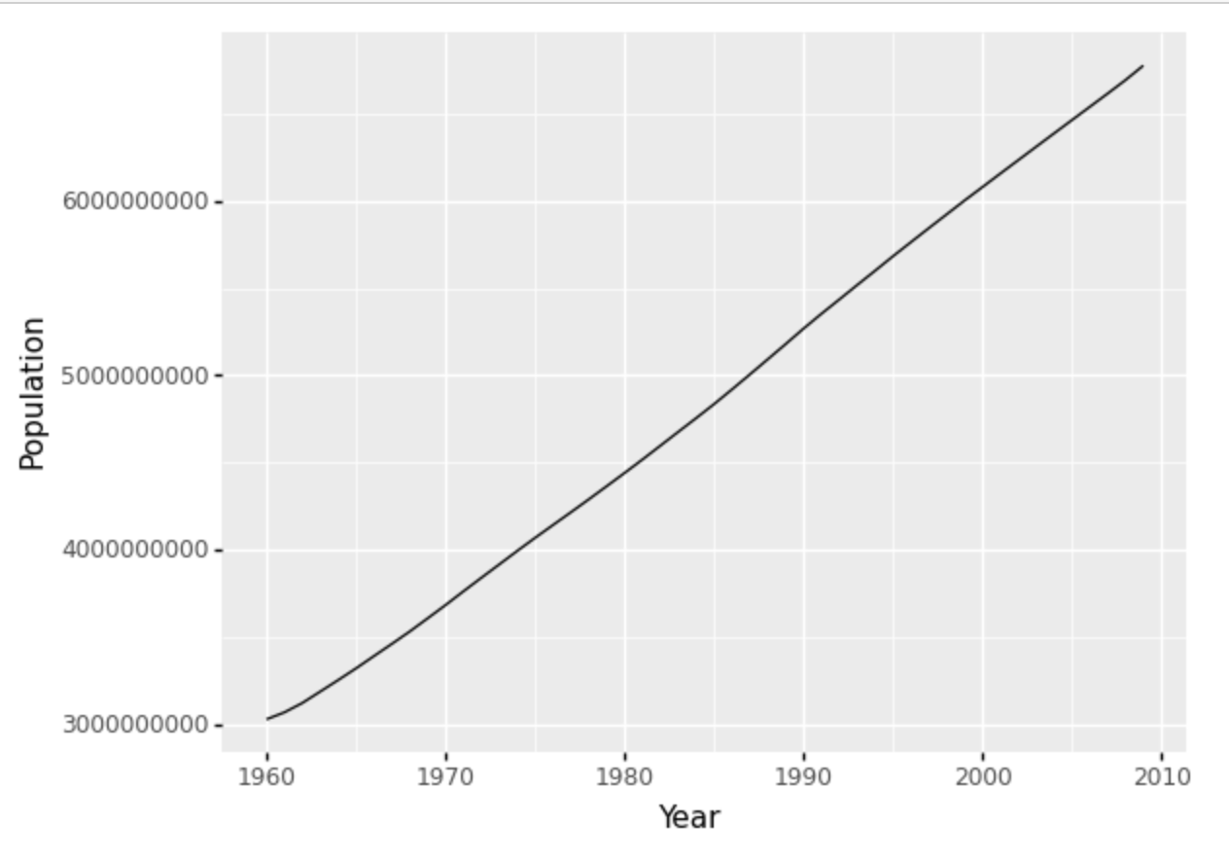

Step Chart

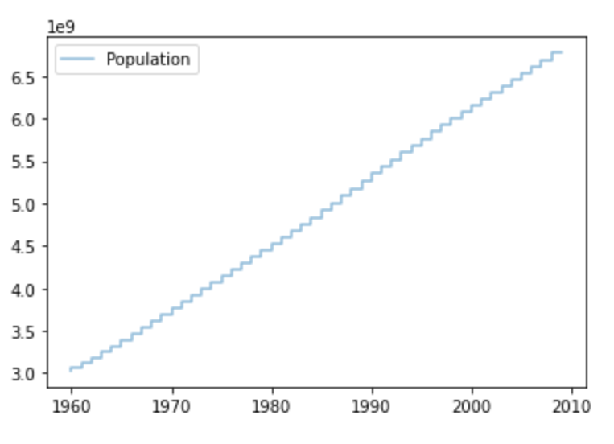

# R

Line Chart

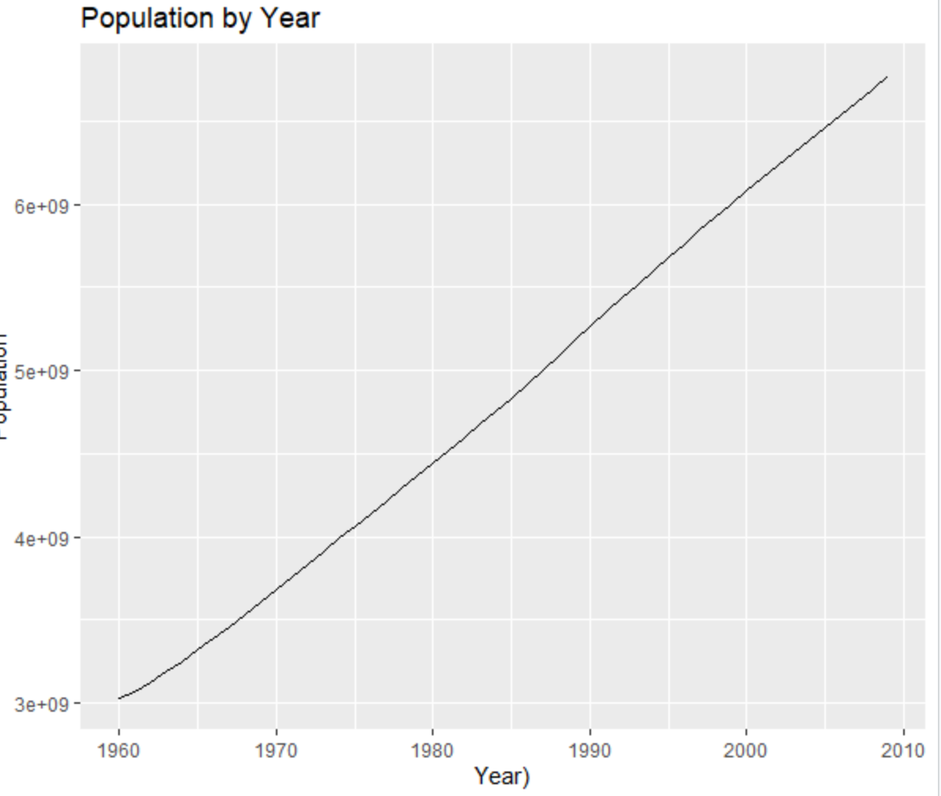

Step Chart

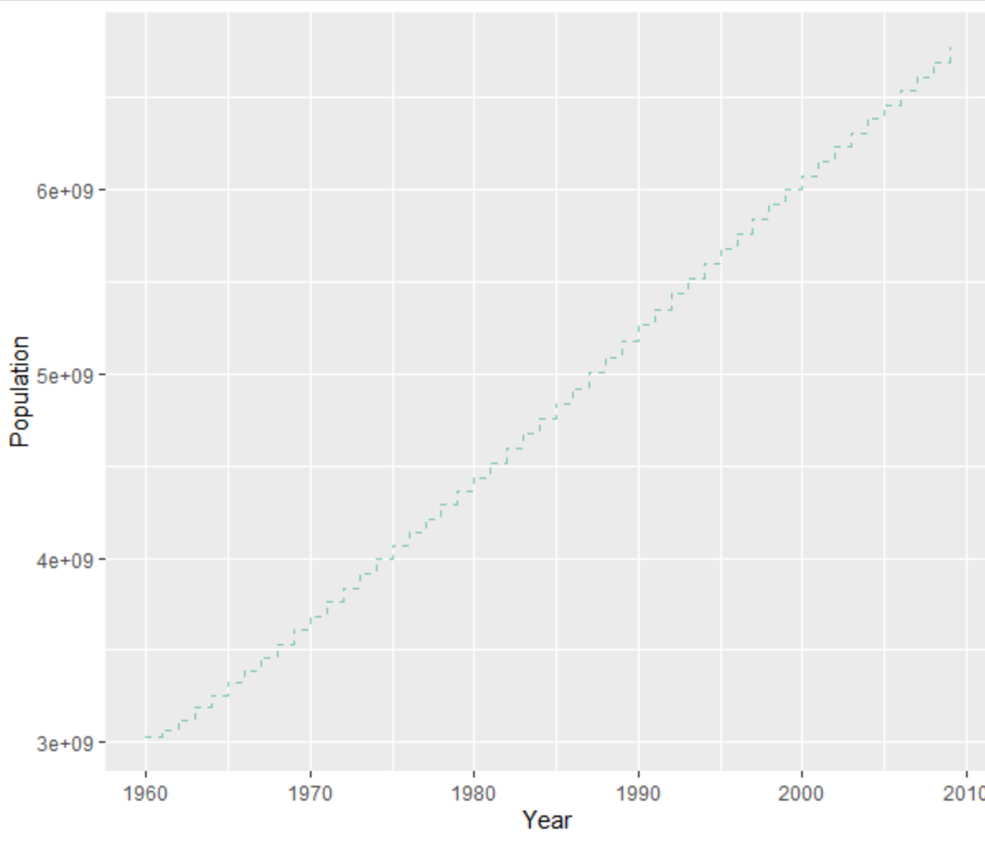

# Power BI

Line Chart

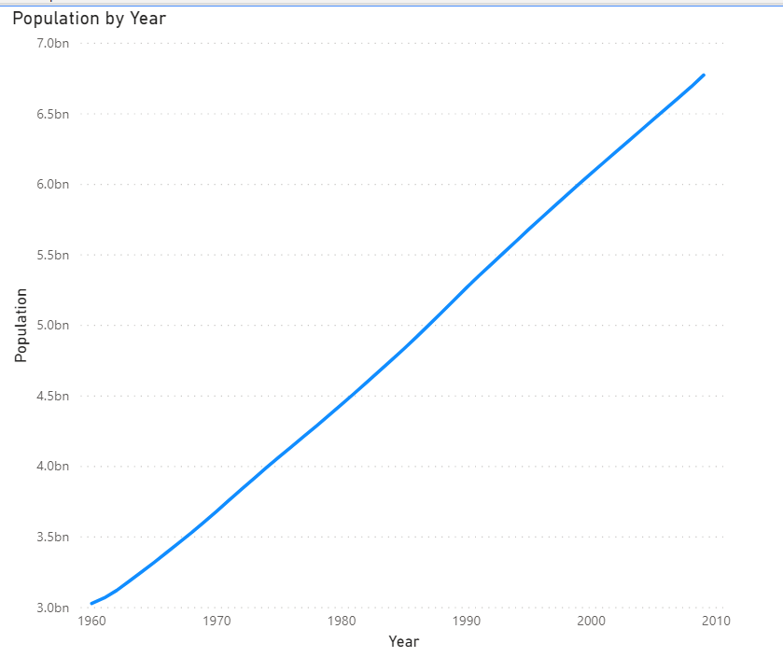

Step Chart

